EXPERIMENT 13
Comparative Analysis of NB-IoT and LTE-M for an IoT Sensor Application
Aim
To compare the performance of NB-IoT and LTE-M for IoT sensor applications by analyzing throughput, latency, packet delivery ratio (PDR), and transmission energy using MATLAB.
Procedure
- Open MATLAB and create a new script.
- Define packet size, data rate, latency, packet delivery probability and transmission power.
- Calculate the effective throughput for both technologies.
- Calculate the packet delivery ratio.
- Estimate transmission energy per packet.
- Calculate energy per successfully delivered payload bit.
- Display the results in a table.
- Plot throughput, latency, PDR and energy comparisons.
MATLAB Program
clc;
clear;
close all;

% Input parameters
N = 10;
sensorRate = 10; % kbps per sensor
bandwidth = 1000; % kbps
networkDelay = 0.05; % seconds

edgeProcess = 0.02;
cloudProcess = 0.01;
reduction = 0.90;

txPower = 0.5;
edgePower = 1;
cloudPower = 5;

% Data rate calculations
rawRate = N * sensorRate;

edgeRate = rawRate * (1-reduction);
cloudRate = rawRate;

% Transmission time for one-second data batch
edgeTxTime = edgeRate / bandwidth;
cloudTxTime = cloudRate / bandwidth;

% Response time
edgeLatency = edgeProcess + edgeTxTime;
cloudLatency = cloudProcess + networkDelay + cloudTxTime;

% Bandwidth utilization
edgeUtil = (edgeRate/bandwidth)*100;
cloudUtil = (cloudRate/bandwidth)*100;

% Energy calculation
edgeEnergy = edgePower*edgeProcess + txPower*edgeTxTime;
cloudEnergy = cloudPower*cloudProcess + ...
txPower*(networkDelay+cloudTxTime);

% Display results
fprintf('Raw Data Rate: %.2f kbps\n',rawRate);
fprintf('Edge Data Rate: %.2f kbps\n',edgeRate);
fprintf('Cloud Data Rate: %.2f kbps\n',cloudRate);

fprintf('Edge Latency: %.4f seconds\n',edgeLatency);
fprintf('Cloud Latency: %.4f seconds\n',cloudLatency);

fprintf('Edge Utilization: %.2f %%\n',edgeUtil);
fprintf('Cloud Utilization: %.2f %%\n',cloudUtil);

fprintf('Edge Energy: %.4f J\n',edgeEnergy);
fprintf('Cloud Energy: %.4f J\n',cloudEnergy);

% Comparison graphs
figure;
bar([edgeLatency cloudLatency]);
set(gca,'XTickLabel',{'Edge','Cloud'});
ylabel('Response Time (seconds)');
title('Edge vs Cloud Latency');
grid on;

figure;
bar([edgeRate cloudRate]);
set(gca,'XTickLabel',{'Edge','Cloud'});
ylabel('Data Rate (kbps)');
title('Remote Data Rate Comparison');
grid on;

figure;
bar([edgeEnergy cloudEnergy]);
set(gca,'XTickLabel',{'Edge','Cloud'});
ylabel('Energy (J)');
title('Energy Consumption Comparison');
grid on;
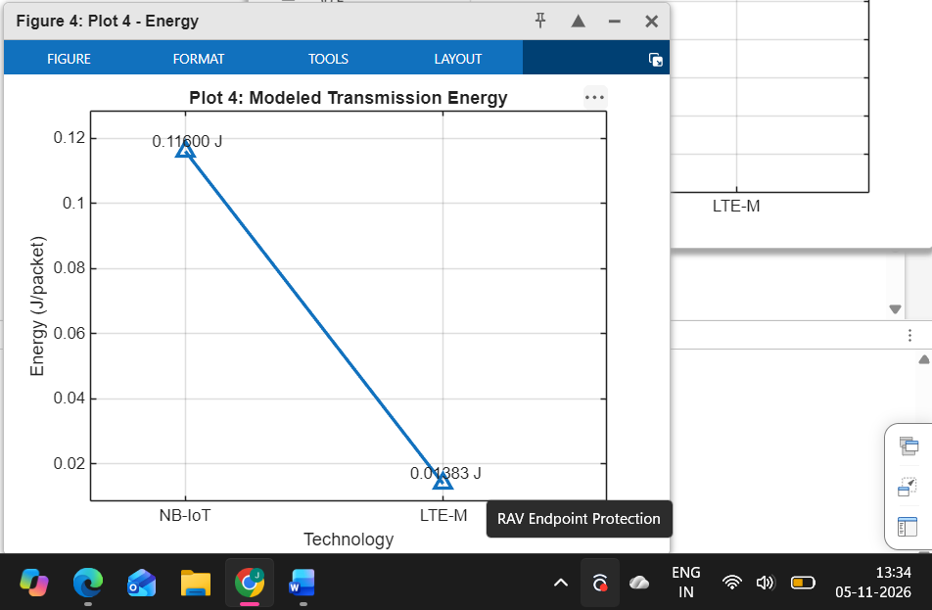
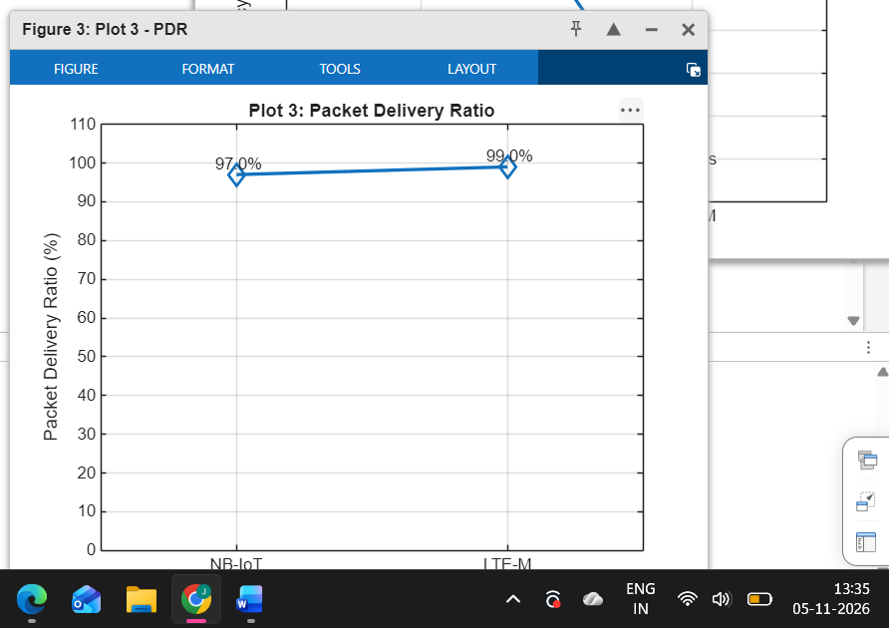

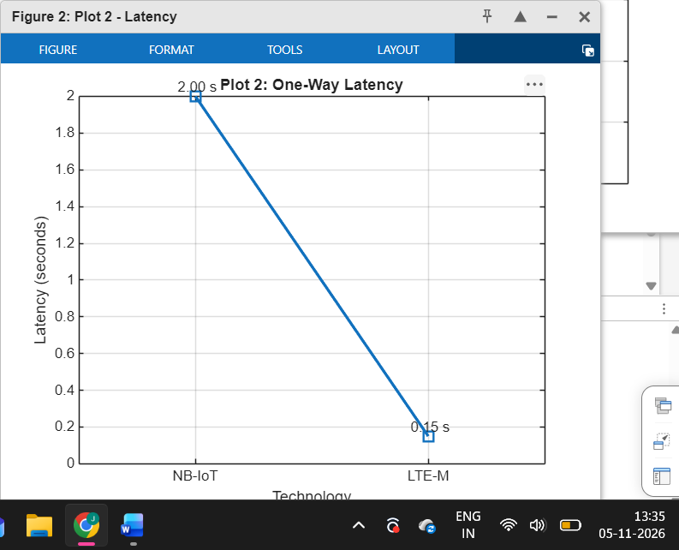

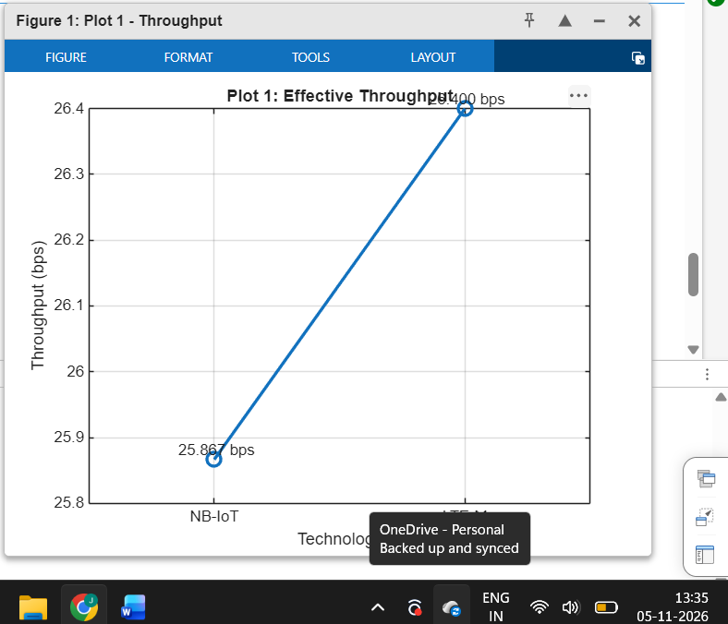
Result
The comparative analysis of NB-IoT and LTE-M was successfully performed using MATLAB. LTE-M showed higher throughput and lower latency under the selected assumptions. Both technologies showed improved packet delivery performance under reliable network conditions. Transmission energy was also estimated for both technologies.

